Test Case Document

Objective: To test all major functionalities of the Student Management System.

TEST CASE ID | Function | Input | Expected Output | Actual Output | Status
TC01 | Add Student | Valid Student Details | Student added successfully | Student added | Pass
TC02 | Add Student | Empty fields | Error message display | Error displayed | Pass
TC03 | Add Student | Nonnumeric marks | Validation error | Validation error displayed | Pass
TC04 | Search Student | Existing ID | Student details displayed | Correct output shown | Pass
TC05 | Search Student | Invalid ID | Student not found | Correct message displayed | Pass
TC06 | Update Student | Valid details | Record updated | Updated successfully | Pass
TC07 | Delete Student | Invalid ID | Student not found | Correct message displayed | Pass
TC08 | Delete Student | Existing ID | Record deleted | Deleted successfully | Pass

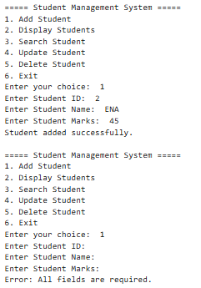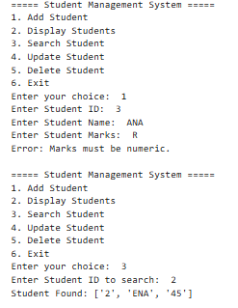
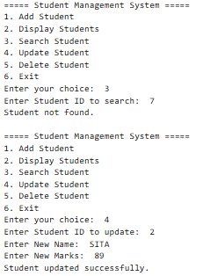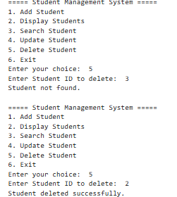

Conclusion:
All major functionalities were tested successfully. Input validation and file handling worked correctly without major errors.

